**National University of Computer & Emerging Sciences**

**Karachi Campus**



**Database System**

**(CS – 2005)**

**Inventory Management System (POS)**

**Project Report**

**Sec-5F**

**Group Members:**

*Awesh Kumar (21k-4526)*

*Hussain Malik (21k-4576)*

*Muhammad Talal (21k-4892)*

Introduction:

The provided database code establishes the foundation for an Inventory Management System through the creation of tables such as categories, media, products, sales, users, and user_groups. Each table is meticulously designed with defined fields to capture essential information, ensuring the systematic organization of data. The relationships between tables are maintained through carefully crafted constraints, such as foreign keys, providing integrity and coherence to the overall database structure. Data insertion examples showcase the versatility of the system in handling diverse product information, sales transactions, and user details.

Specifically, the users table includes entries for different user levels, such as administrators, special users (e.g., suppliers), and standard users (e.g., sellers). The user_groups table plays a pivotal role in categorizing users into distinct levels, like 'Admin', 'Special', and 'User'. For instance, the 'Admin' user level is associated with privileges that allow comprehensive system control, while 'Special' users may have specific functions, and 'User' accounts are designed for regular sellers. This sophisticated user management setup ensures secure and role-specific access to the Inventory Management System, enhancing both data protection and operational efficiency.

This comprehensive database design not only serves as a robust backbone for inventory management but also lays the groundwork for a scalable and efficient system with distinct roles for administrators, special users (suppliers), and standard users (sellers). In this report, we delve into the intricacies of this database design, exploring its architecture, key features, and the nuanced user management system that supports dynamic roles within the Inventory Management System.

Problem Statement:

The Inventory Management System currently faces challenges stemming from an ambiguous user management structure. The lack of clear role distinctions between administrators, special users (such as suppliers), and standard users (sellers) leads to potential security vulnerabilities and operational inefficiencies. The absence of a well-defined login setup exacerbates these issues, hindering the system's ability to provide secure and role-specific access. Furthermore, the user interface lacks intuitive features, impacting user experience and overall system effectiveness. Addressing these challenges is crucial for enhancing security, operational efficiency, and user satisfaction within the Inventory Management System.

Entity Relationship Diagram:

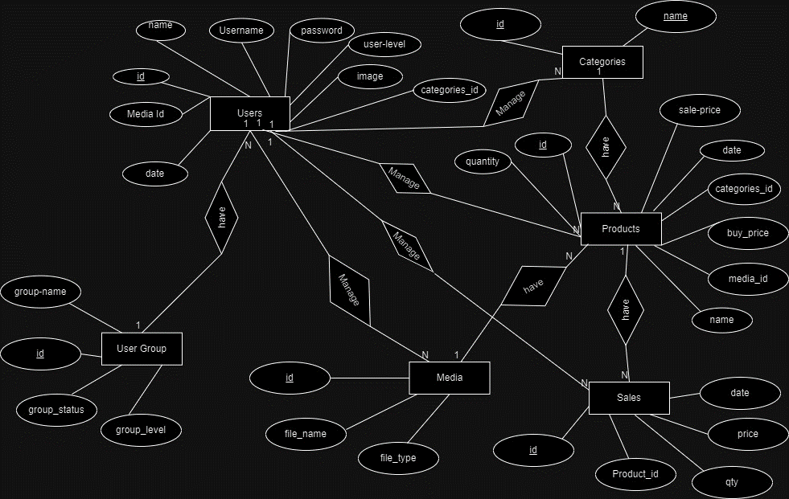

Relational Schema following 3NF:

Unnormalized Schema:

Products

|  |  |  |  |
| --- | --- | --- | --- |
| Id | Name | Buy_price | Sale_price |
| Category_name | Media_id | Date |  |

Sales

|  |  |  |  |  |
| --- | --- | --- | --- | --- |
| Id | Product_id | qty | price | Date |

Users

|  |  |  |  |  |  |
| --- | --- | --- | --- | --- | --- |
| Id | Name | username | password | userlevel | Image |
| status | Last_login | groupname | grouplevel | Groupstatus |  |

Media

|  |  |  |
| --- | --- | --- |
| Id | File_name | File_type |

Normalized Schema:

In Table Products Redundant data is present as table contain repeated category names for each product. This violates the principles of the 1st normal form.

Steps:

Identify Primary Key:

The id in the Products table is a suitable primary key.

Eliminate Repeating Groups:

Move the name from the Products table to a new Categories table. This will remove the repeating groups and create a separate table for categories.

Update Foreign Key:

In the products table, replace the categorie_id with a foreign key reference to the categories table.

Products

|  |  |  |  |
| --- | --- | --- | --- |
| Id | Name | Quantity | buy_price |
| Sale_price | Categories_id | Media_id | Date |

Categoreis

|  |  |
| --- | --- |
| Id | Name |

The Users table has data dependencies between user-related and group-related. For example, the user_level is dependent on the group_level. This violates the principles of the 2nd normal form.

Steps:

Identify Primary Key:

The id in the users table is a suitable primary key.

Eliminate Repeating Groups:

Move the group_name, group_level, and group_status fields from the users table to a new user_groups table. This will remove the repeating groups and create a separate table for user groups.

Update Foreign Key:

In the users table, replace the user_level field with a foreign key reference to the user_groups table.

Users

|  |  |  |  |
| --- | --- | --- | --- |
| Id | Name | Username | Password |
| userlevel | image | Status | Last_login |

User_groups

|  |  |  |  |
| --- | --- | --- | --- |
| Id | Group_name | Group_level | Group_staus |

Sales

|  |  |  |  |  |
| --- | --- | --- | --- | --- |
| Id | Product_id | qty | price | Date |

Media

|  |  |  |
| --- | --- | --- |
| Id | File_name | File_type |

Technologies used in Project:

**Database:** MYSQL

**Connectivity**: PHP

**Frontend:** HTML-JS-CSS

Potential users of the project:

1. Cashiers:

• Cashiers are the primary users responsible for processing transactions through the POS system.

• Their tasks involve scanning products, entering item quantities, and generating receipts for internal record-keeping.

2. Inventory Managers:

• Inventory managers use the POS system to track product sales and update stock levels in real-time.

• They rely on the system to manage inventory efficiently, optimize stock replenishment, and prevent stockouts.

3. Sales and Operations Team:

• The sales and operations team utilizes POS data for reporting and analysis.

• They may extract information on product sales, identify popular items, and make informed decisions regarding inventory management and sales strategies.

4. System Administrators:

• System administrators are responsible for maintaining and configuring the POS system.

• They manage user accounts, set access levels, and ensure the overall functionality and security of the system.

Conclusion:

In summary, the Inventory Management System project offers a comprehensive solution catering to various user roles, including administrators, suppliers, and sellers. The well-structured database ensures data security and integrity, while the clear delineation of user privileges enhances system control. The project's user-friendly interface aims to improve accessibility, and the inclusion of IT support ensures ongoing system reliability. With its focus on efficient inventory control and strategic decision-making, the project holds the potential to streamline internal operations and contribute to organizational growth. Ongoing refinement and adaptation will be key to maximizing the system's effectiveness in the dynamic landscape of inventory management.